**World Quant University**

**Professor: Ritabrata Bhattacharyya**

**Alpha Design II**

Nikolas Lippmann Pareschi - [nikolaslippmann@gmail.com](mailto:nikolaslippmann@gmail.com)

Introduction: Spyder PEP8 checker is truly a time saver, as I discovered reading the Piazza forum in Python 2. So, I have used it again for all classes and this Project I from Alpha Design II. I tried my best to avoid using modular code.

**Project: Trading the Optimal F**

### Trading the Optimal F

* + - 1. Write a program that prompts the user to enter any valid stock symbol available in an appropriate financial website such as Google Finance, Yahoo Finance, Quandl, CityFALCON, or another similar source for NYSE & NASDAQ. Ensure proper error handling for wrong user inputs.
      2. Download/access End-of-day data for last 25 years for user entered ticker from an appropriate financial website such as Google Finance, Yahoo Finance, Quandl, CityFALCON, or another similar source.

We use the same function that we have used in project 3. The function does error handling.



Code:

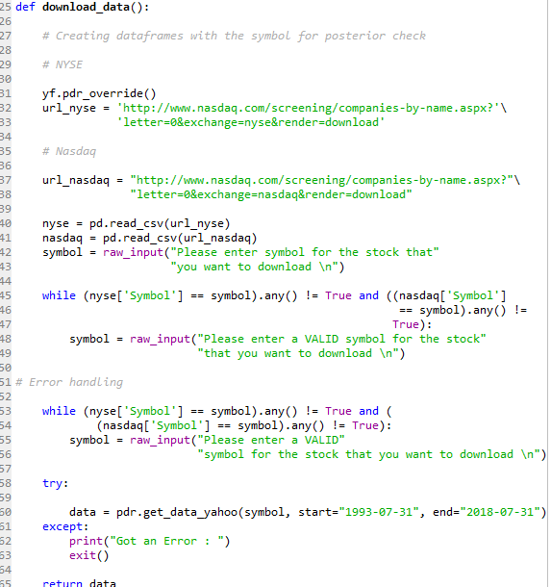

* + - 1. Constitute two trend trading systems:

A n-day Support Resistance Breakout system with a volatility bases trailing stop-loss

An Exponential Moving system where you take open position when prices move 1 ATR on either side of the moving average and close position when prices cross the moving average in the opposite direction

Code with comments:

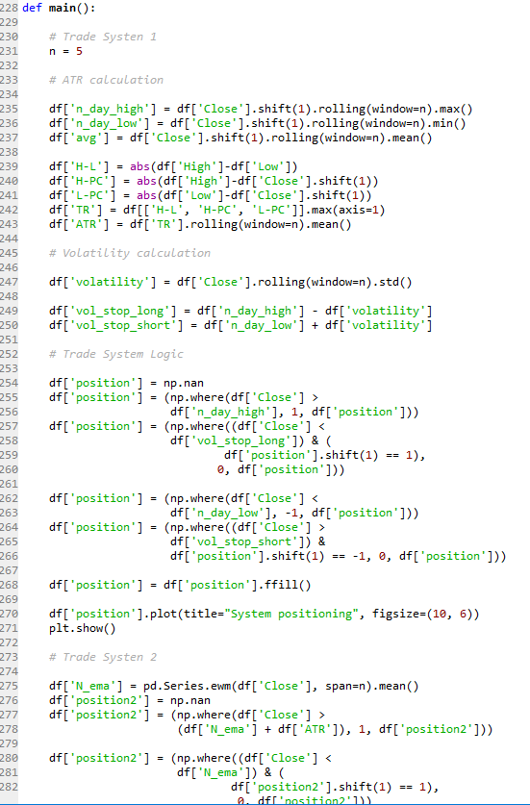

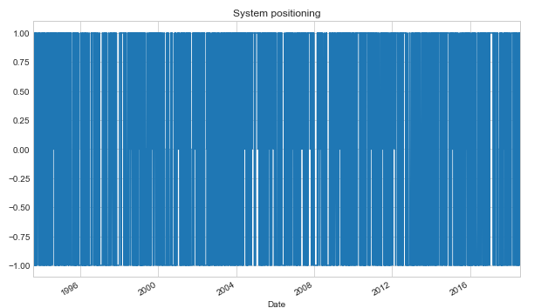 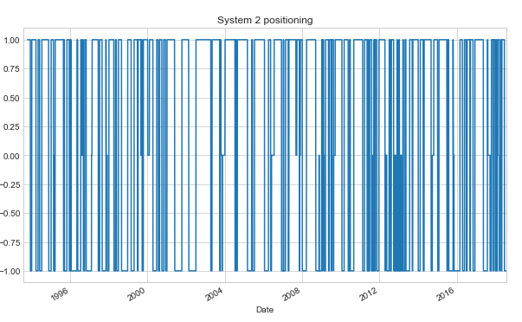

* + - 1. Design and implement a normal upright pyramiding strategy for each of the systems. (Initial entry into trades would be on a fixed amount, and then pyramid on top of it)

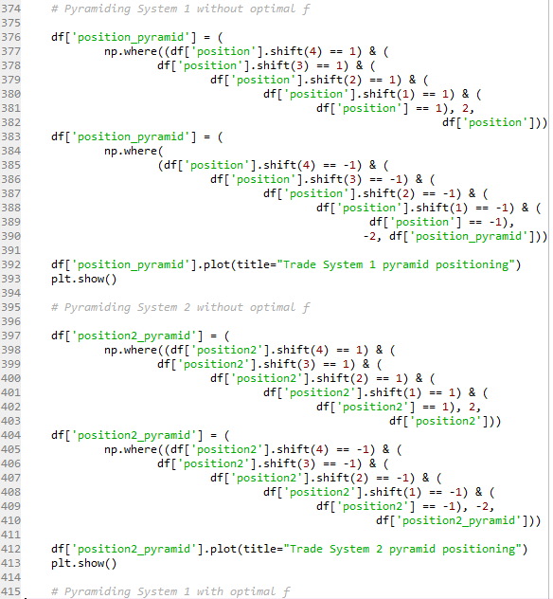

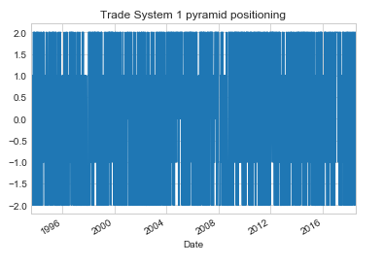 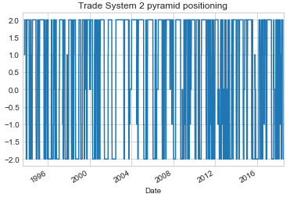

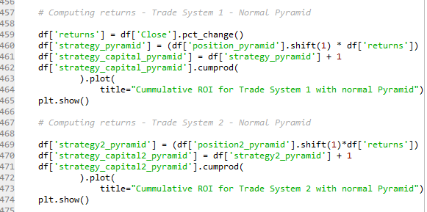

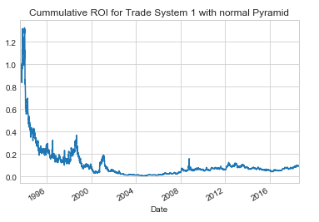

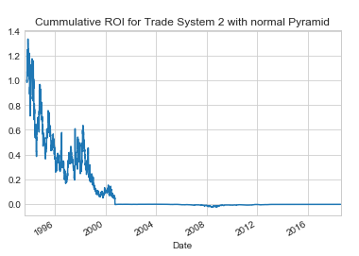

* + - 1. Clearly mention and explain all other trading rules

If the trade system is positioned for 4 days in a row we add a second position.

* + - 1. Backtest the performance of the systems on the first 80% of the downloaded data. Based on the performance, calculate the optimal F for the two systems using the simplified formula

Img1

Where

PLR = the ratio of average profit to average loss  
p = the probability of a winning trade

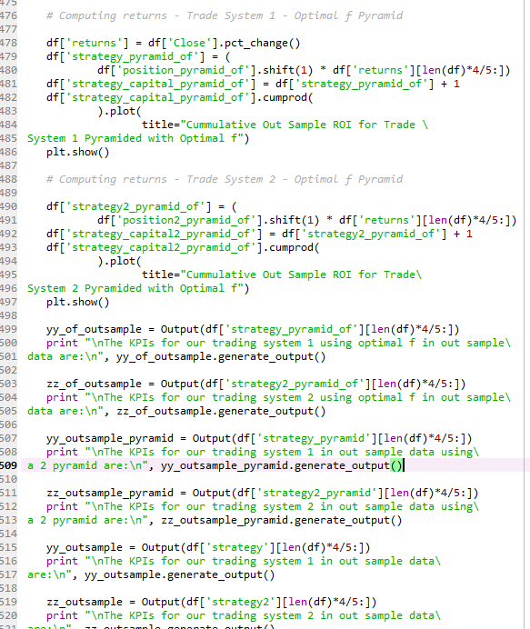

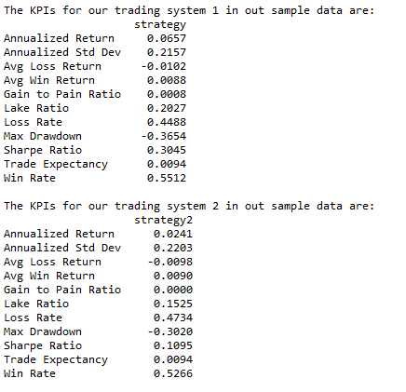

* + - 1. With the newly found values of optimal bet fraction rerun the backtest on out-of-sample data (the 20% remaining data) for both the systems and calculate all the relevant KPIs as marked below

Win %

Win to Loss Ratio

Mean Return Per Trade

Maximum Consecutive Losers

Maximum Drawdown

CAGR

Lake Ratio

Gain to Pain Ratio

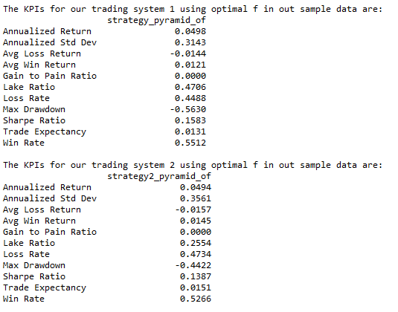

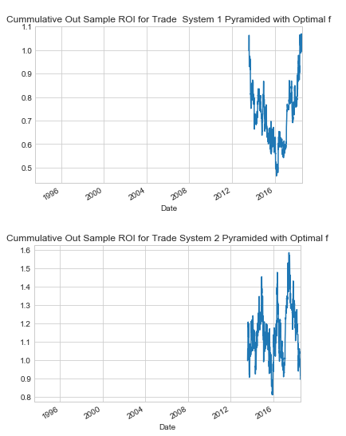

The fact that the system were not very robust made the pyramiding not good. But nevertheless the optimal f was superior than a blind pyramid system in both the trade systems considering AAPL stock.